害羞的熊貓

Shy Panda

在這個專案，我們要做出一隻跳舞熊貓。

In this project you will make a dancing panda.

這是一隻害羞的熊貓，當他跟你對到眼，會覺得很害羞而停止跳舞

It’ll be a shy panda, that will get embarrassed and stop dancing if it sees you looking in through the window.

你要訓練這隻熊貓，當你閉上眼睛時，他會知道你沒有在看他，繼續跳舞，

You’ll train it so that if you cover your eyes, it’ll recognise that you’re not looking and keep dancing.

此專案靈感來自Cassie Evans。

下面網址收錄她所設計的版本：https://codepen.io/cassie-codes/pen/jKaVqo

The idea for this project came from Cassie Evans. You can see her version of it at   
https://codepen.io/cassie-codes/pen/jKaVqo

這隻熊貓的設計來自Ed Moffat。

The panda artwork in this project was by Ed Moffatt from XMPT Games.

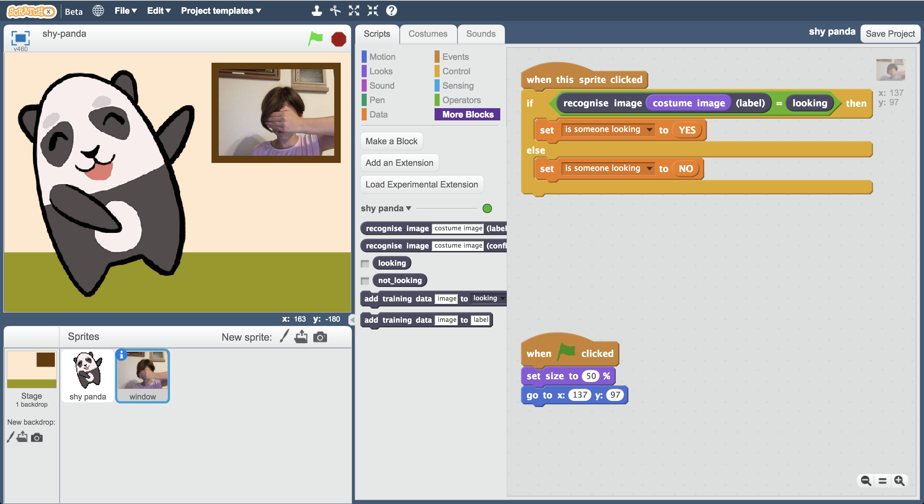

This project worksheet is licensed under a Creative Commons Attribution Non-Commercial Share-Alike License

http://creativecommons.org/licenses/by-nc-sa/4.0/

1. 搜尋網頁：<https://machinelearningforkids.co.uk/>

Go to <https://machinelearningforkids.co.uk/> in a web browser

1. 點選“**Get started**”

Click on “**Get started**”

1. 點選“**Log In**”按鈕並登入系統

*如果你沒有帳號，請你的老師幫你建立一個帳號。*

*如果你不記得你的帳號或密碼，請你的老師幫你重新設定一次。*

Click on “**Log In**” and type in your username and password  
*If you don’t have a username, ask your teacher to create one for you.  
If you can’t remember your password, ask your teacher to reset it for you.*

1. 點選上方清單中的 **”Projects”** 按鈕

Click on “**Projects**” on the top menu bar

1. 點選 “**+ Add a new project**” 按鈕

Click the **“+ Add a new project**” button.

1. 將你的專案命名為 “shy panda”並設定成辨識 “**images**”類別，點

選 “**Create**”按鈕

Name your project “shy panda” and set it to learn how to recognise “**images**”. Click the “**Create**” button  
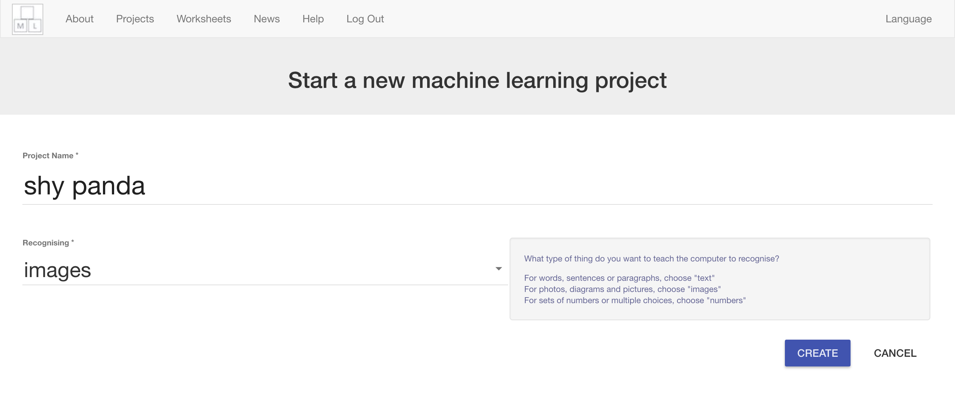

1. 你會在專案清單中看到“**chameleon**”，點選此專案

You should see “**shy panda**” in the list of your projects. Click on it.  
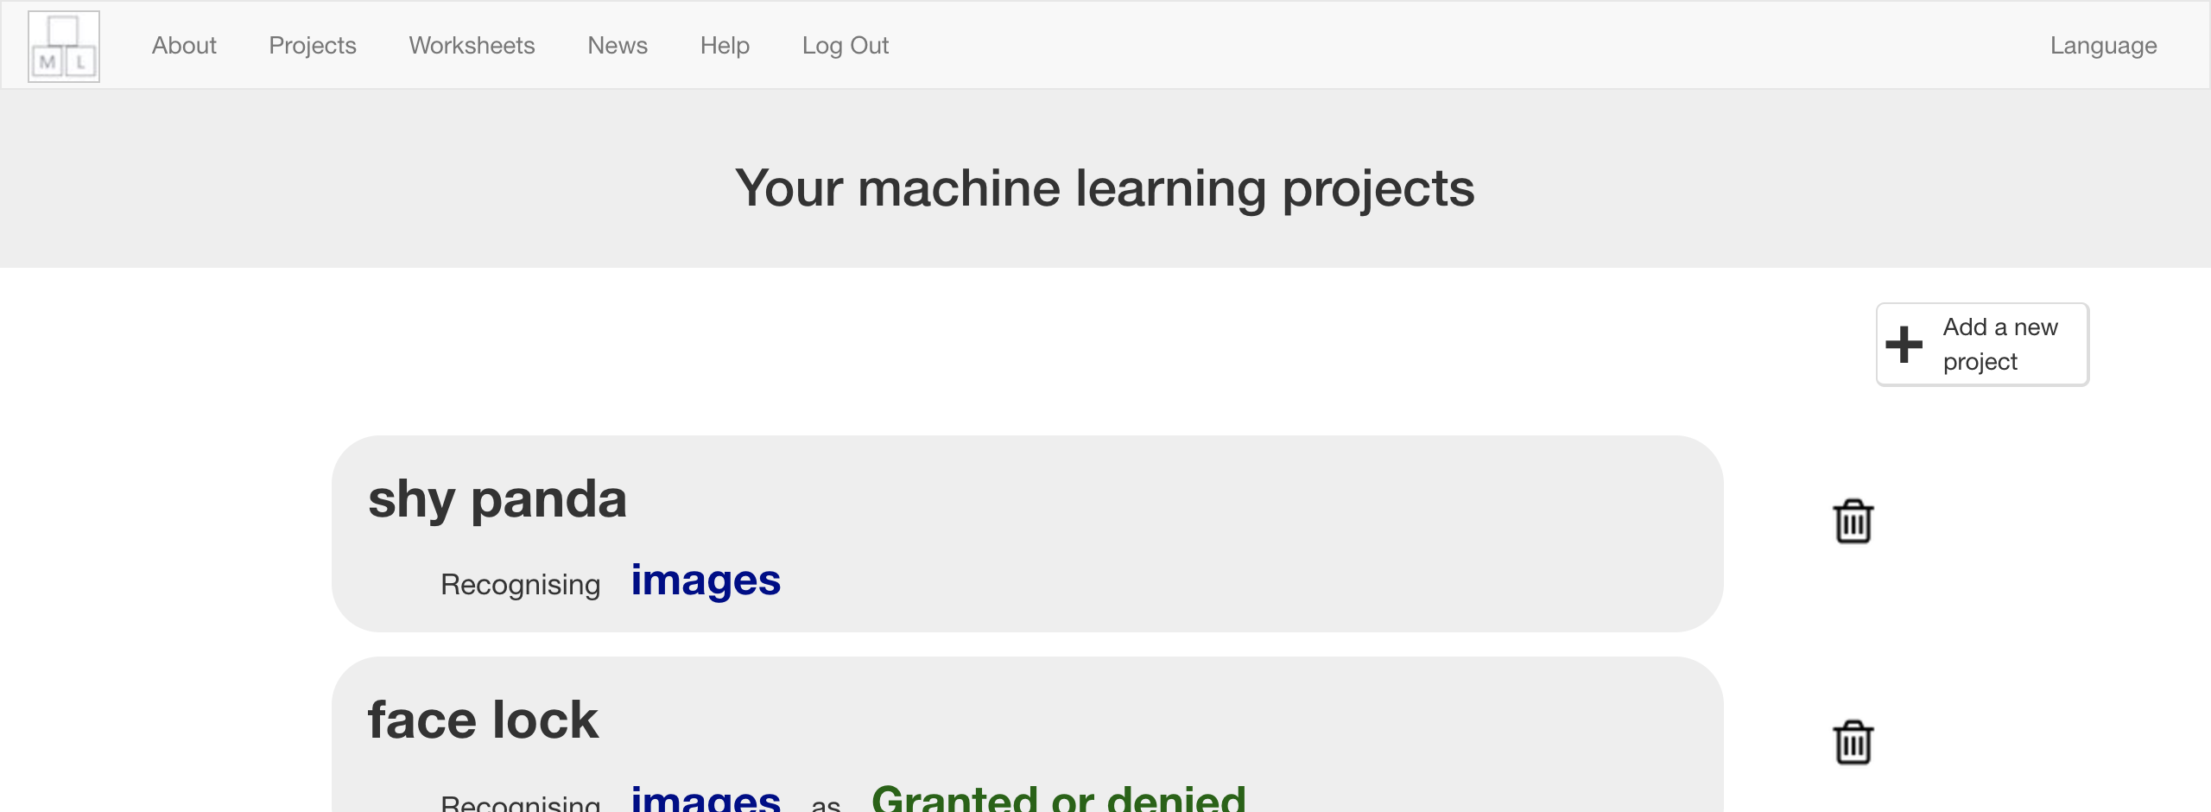

1. 點選**Train**按鈕

Click the **Train** button  
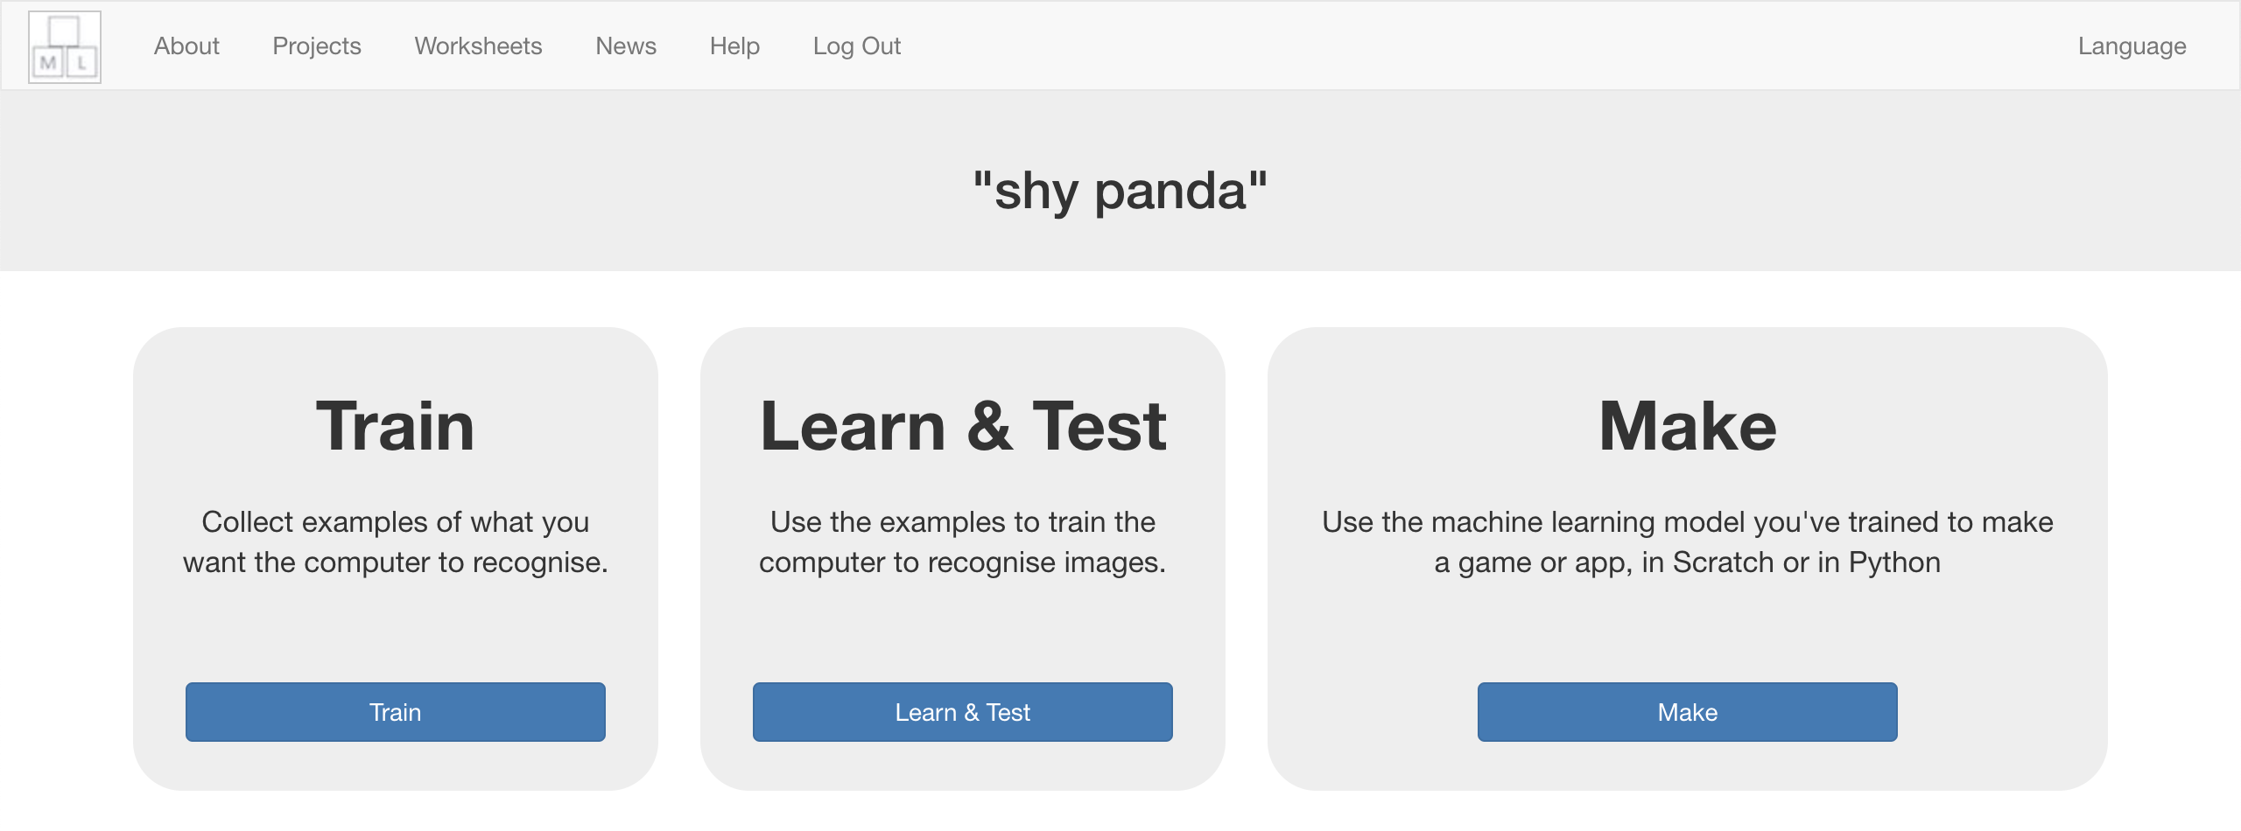

1. 點選“**+ Add new label**”按鈕

Click “**+ Add new label**”  


1. 輸入“looking”，點選**Add**

Type in “looking”, and press **Add**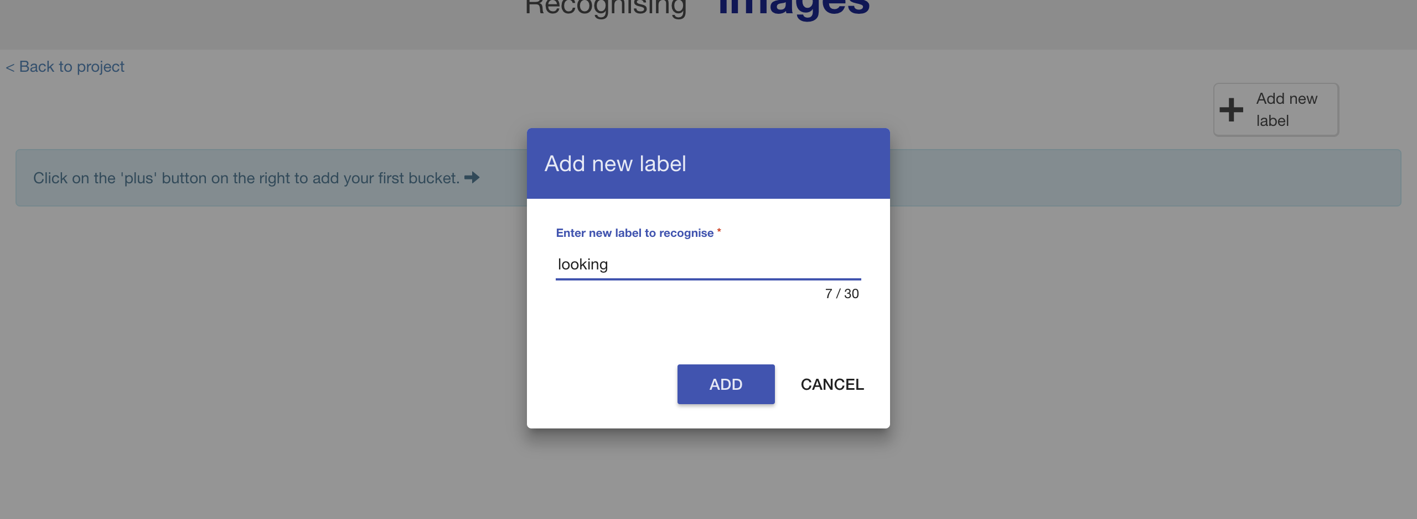

1. 重複上個步驟，這次改輸入“not looking”

Do that again, but this time add “not looking”  
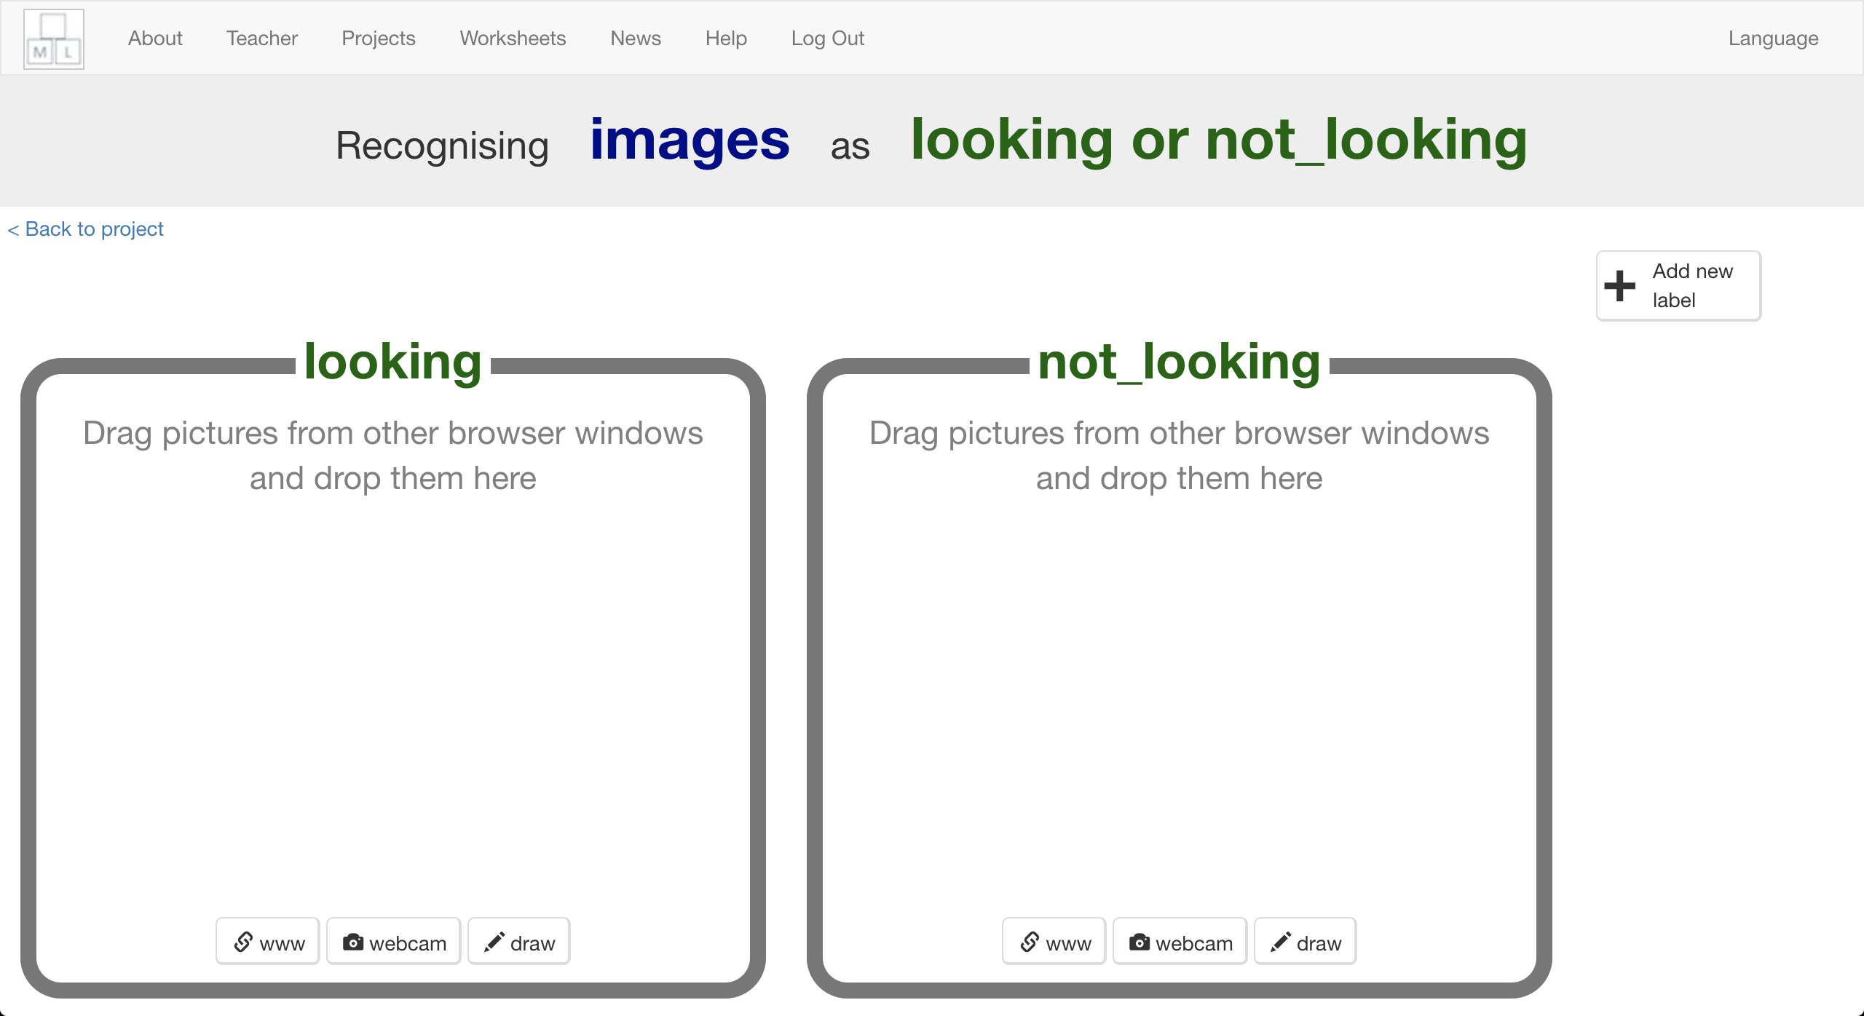

1. 點選“not looking”方框中的“**webcam**”按鈕

Click on the “**webcam**” button in the “not looking” bucket  
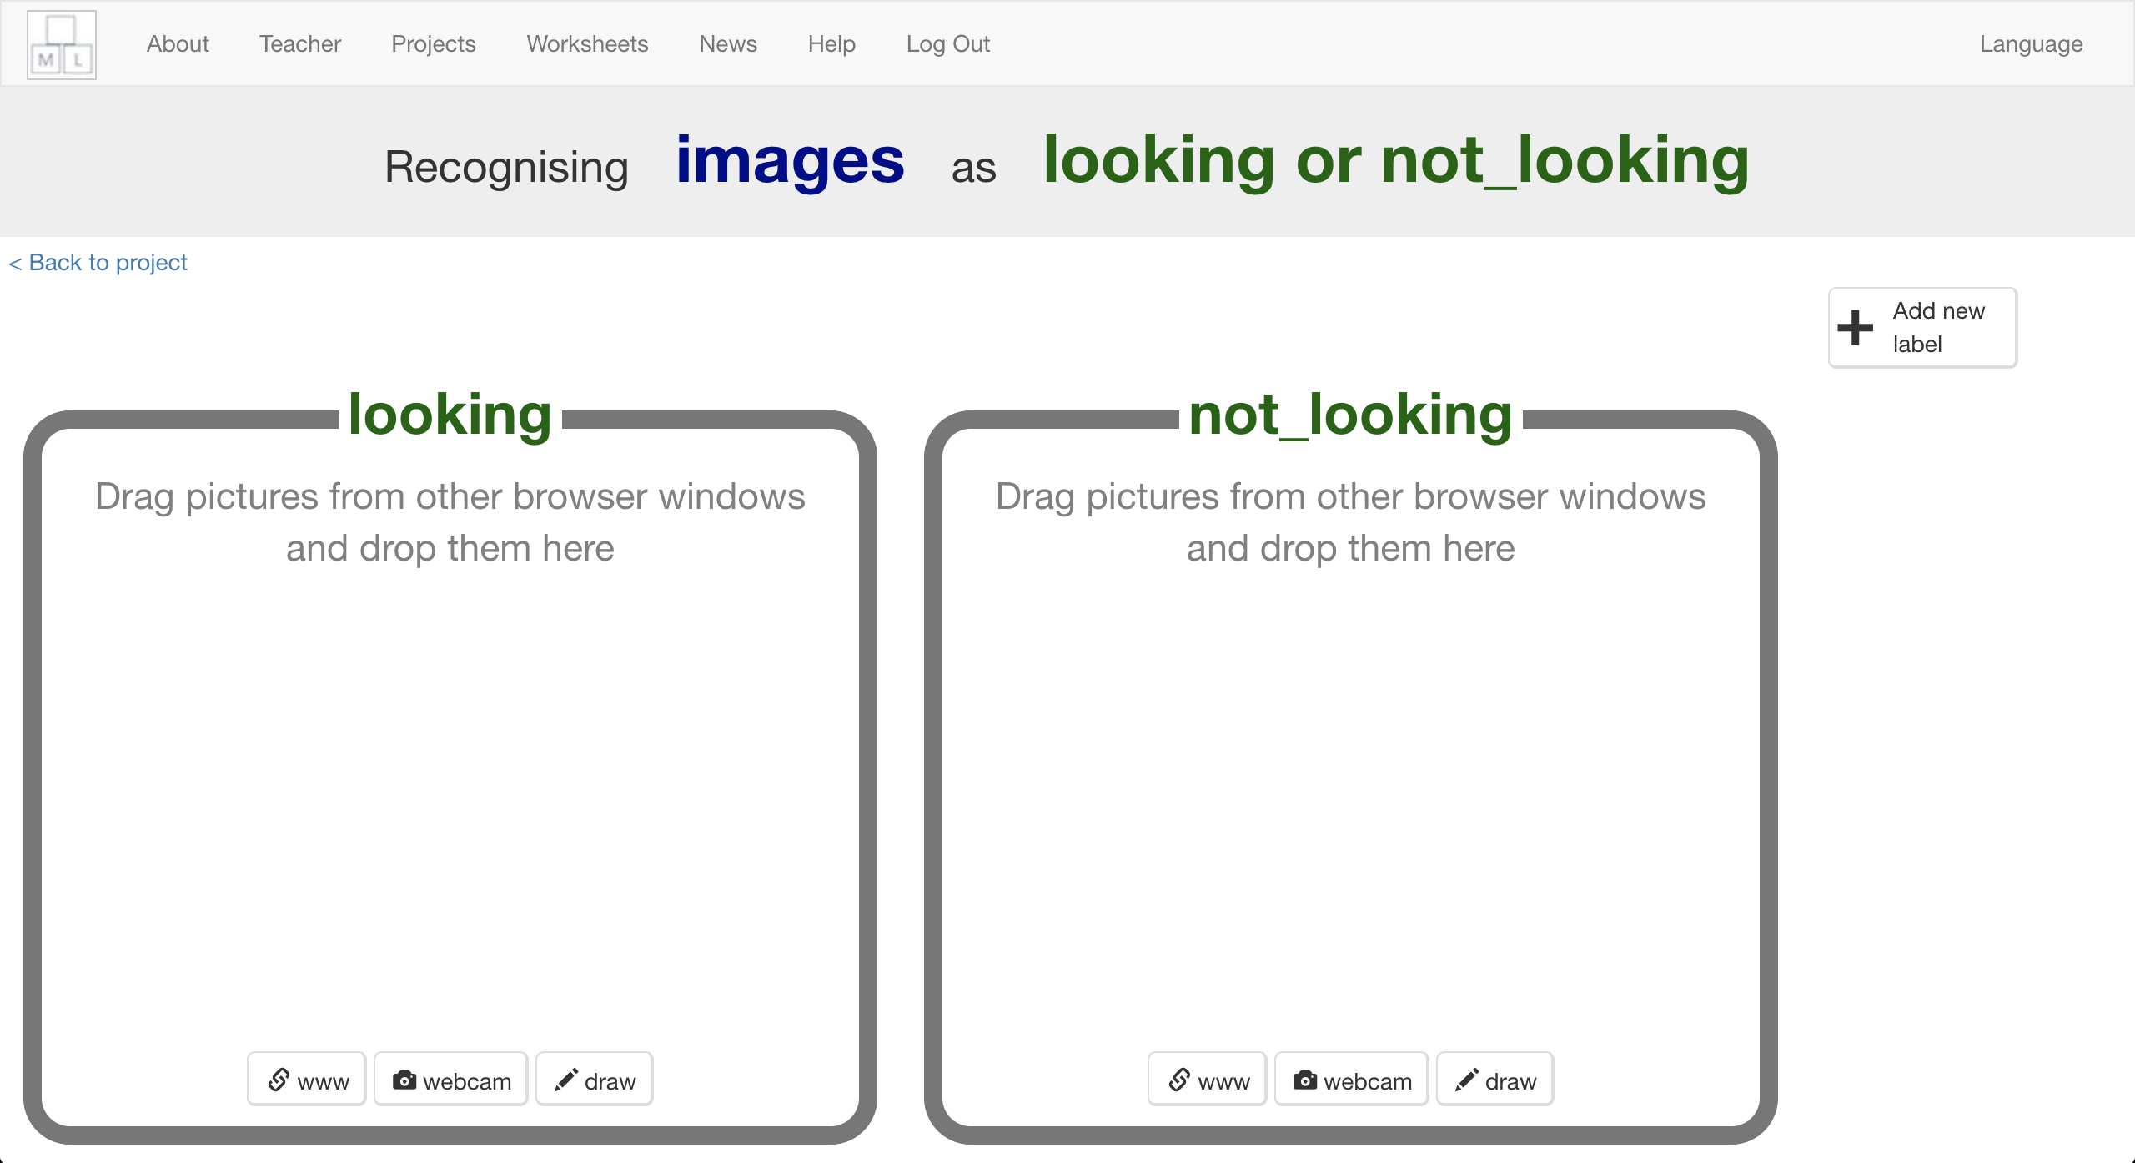

1. 用你的手遮住臉，然後拍一張照片

*最好能找個夥伴幫忙你！*

Cover your face with your hands, and take a photo   
*It might be easier if you have a partner to click the “Add” button for you!*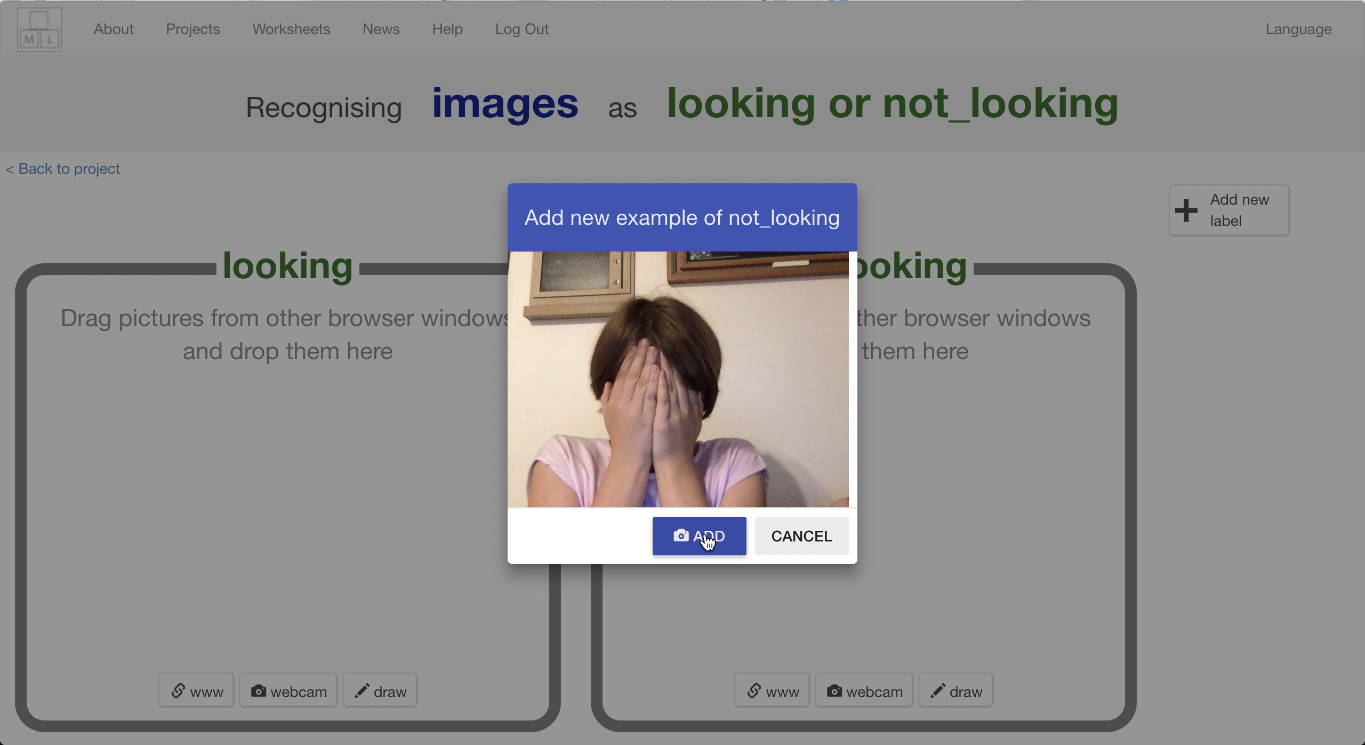

1. 重複上個步驟直到你有**10張**這樣的照片

Repeat until you’ve got **ten photos** like this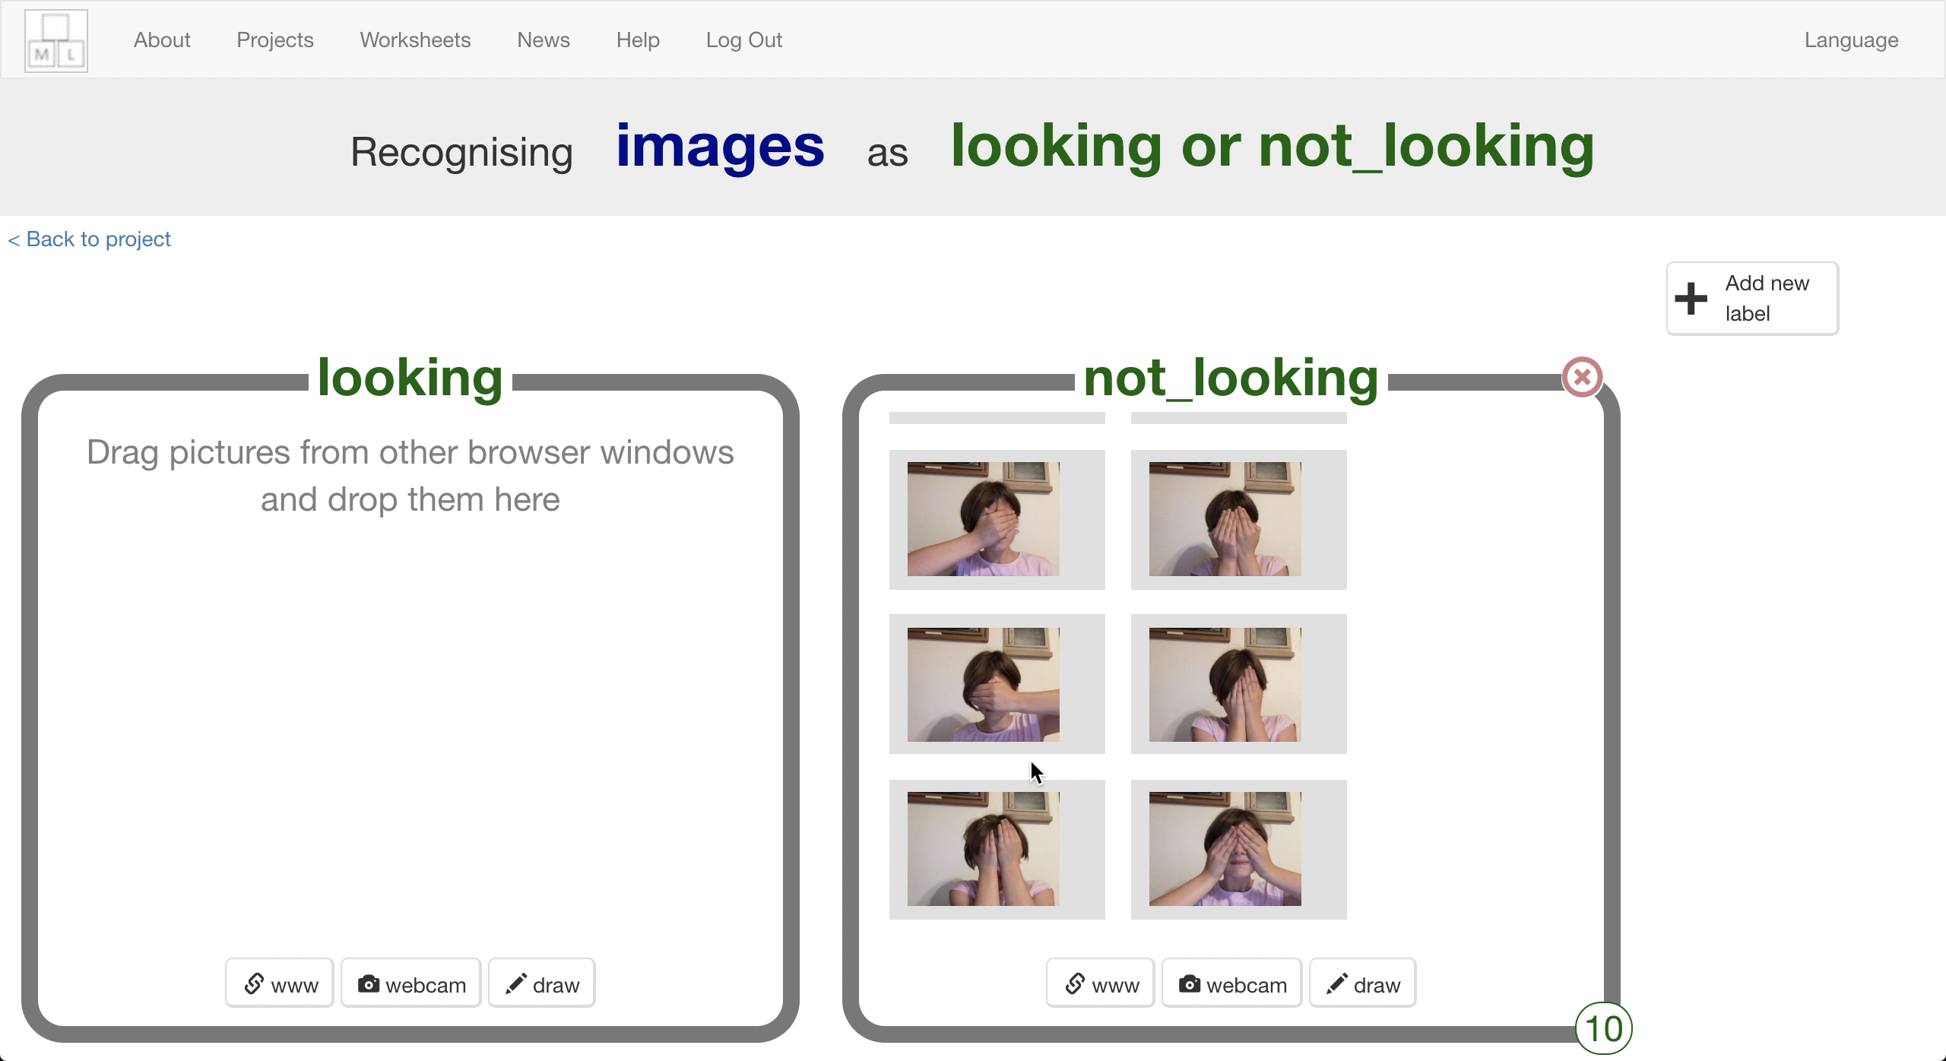

1. 點選“looking”方框中的“**webcam**”按鈕

Click the “**webcam**” button in the “looking” bucket  
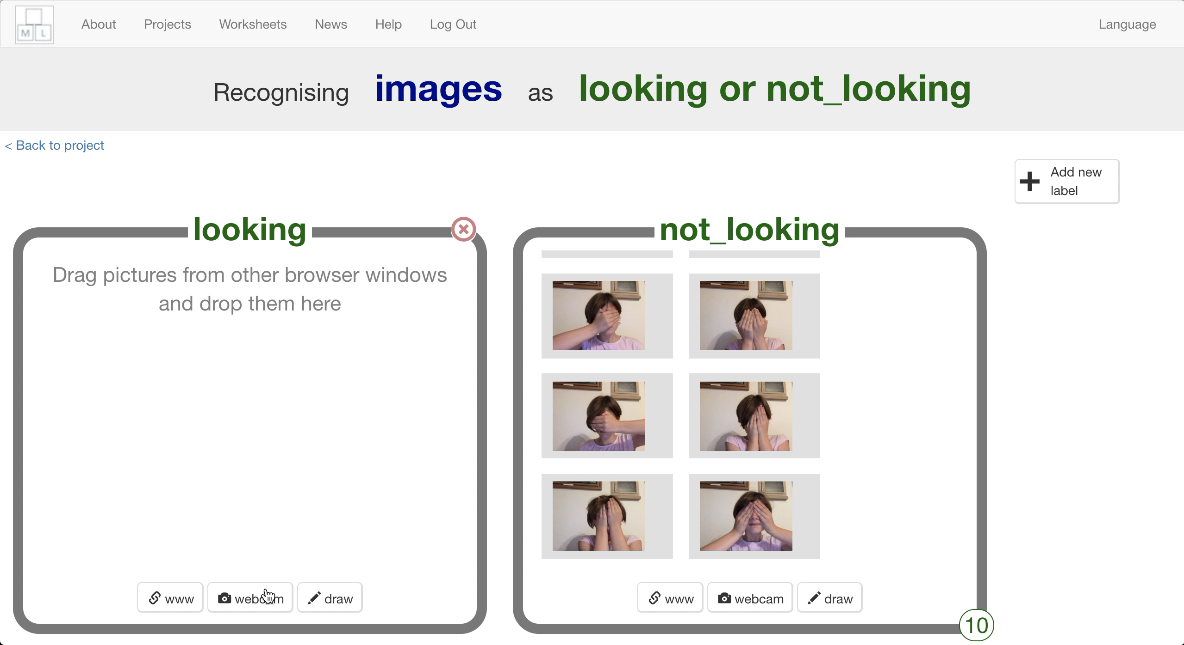

1. 眼睛看著鏡頭，然後點選“**Add**”

Look at the camera and click “**Add**”  
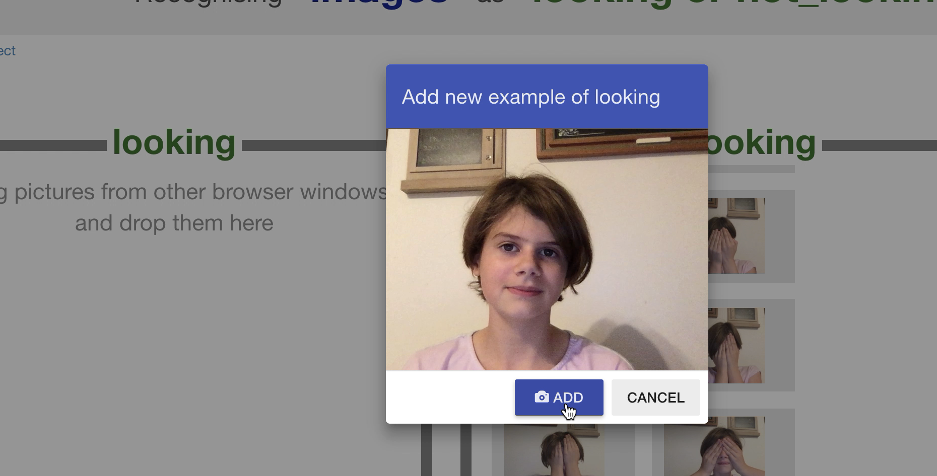

1. 重複直到你有**10張**這樣的照片

Repeat until you’ve got **ten photos** like this  
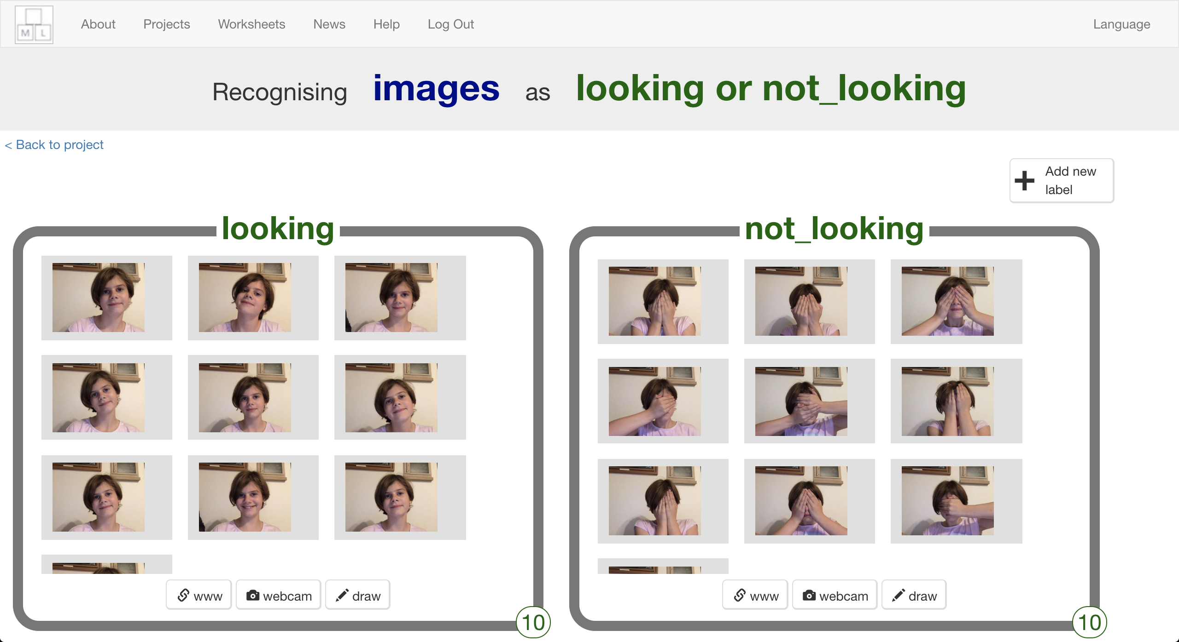

1. 點選“**< Back to project**”

Click “**< Back to project**”

1. 點選**Learn & Test**

Click **Learn & Test**

1. 點選“**Train new machine learning model**”，電腦可能需要幾分鐘的時間來訓練模型

Click the “**Train new machine learning model**” button  
*It might take a few minutes for the model to train.**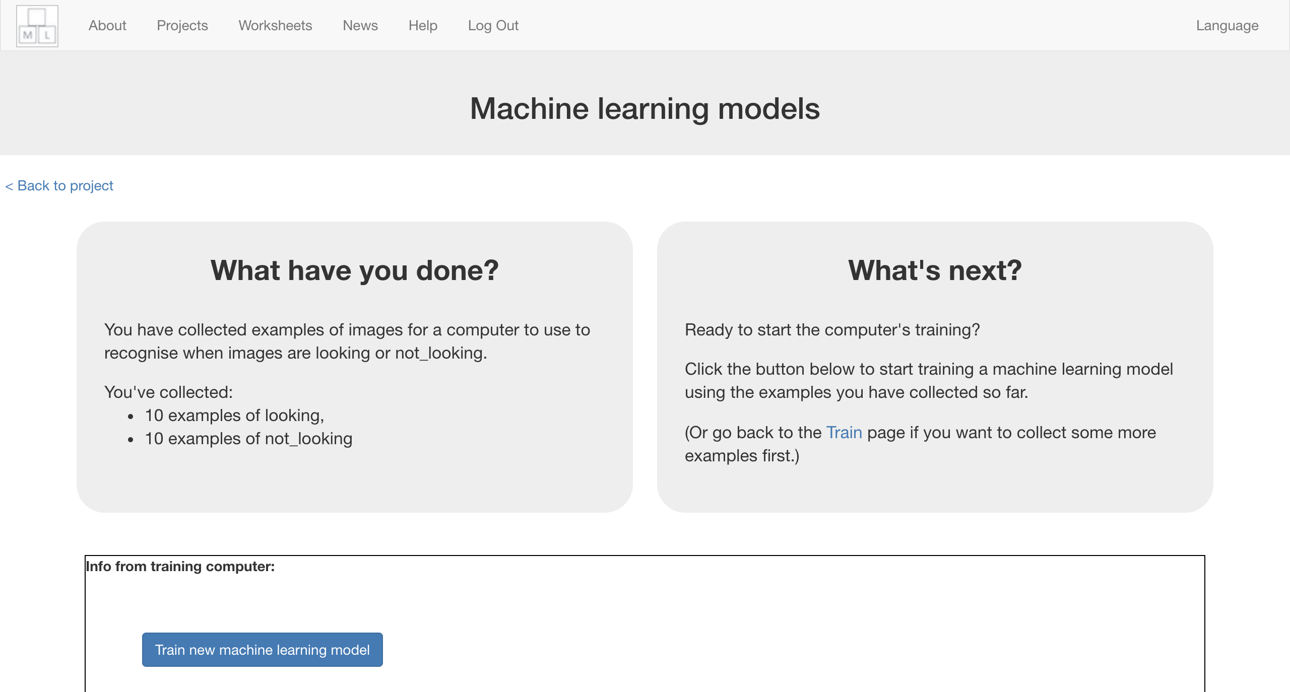*

**到目前為止，你做了哪些事情？**

**What have you done so far?**

你開始訓練電腦辨別一張照片中的臉是否被遮住。你用拍攝範例照片的方式來訓練一個機器學習『模型』。

You’ve started to train a computer to recognise whether photos of a face and photos of a covered face. You are doing it by taking example photos. These examples are being used to train a machine learning “model”.

這就是所謂的『監督式學習』，因為你在這個過程中確保（監督）電腦收到的結果是正確的 (supervised learning)。

This is called “supervised learning” because of the way you are supervising the computer’s training.

電腦會從範例照片中找尋共通模式，這些模式會被拿來辨識新照片。

The computer will learn from patterns in the shapes from each of the photos you’ve given it. These will be used to recognise new photos.

1. 點選“**< Back to project**”

Click “**< Back to project**”

1. 點選“**Make**”按鈕

Click the “**Make**” button

1. 點選“**Scratch 3**”

Click “**Scratch 3**”  
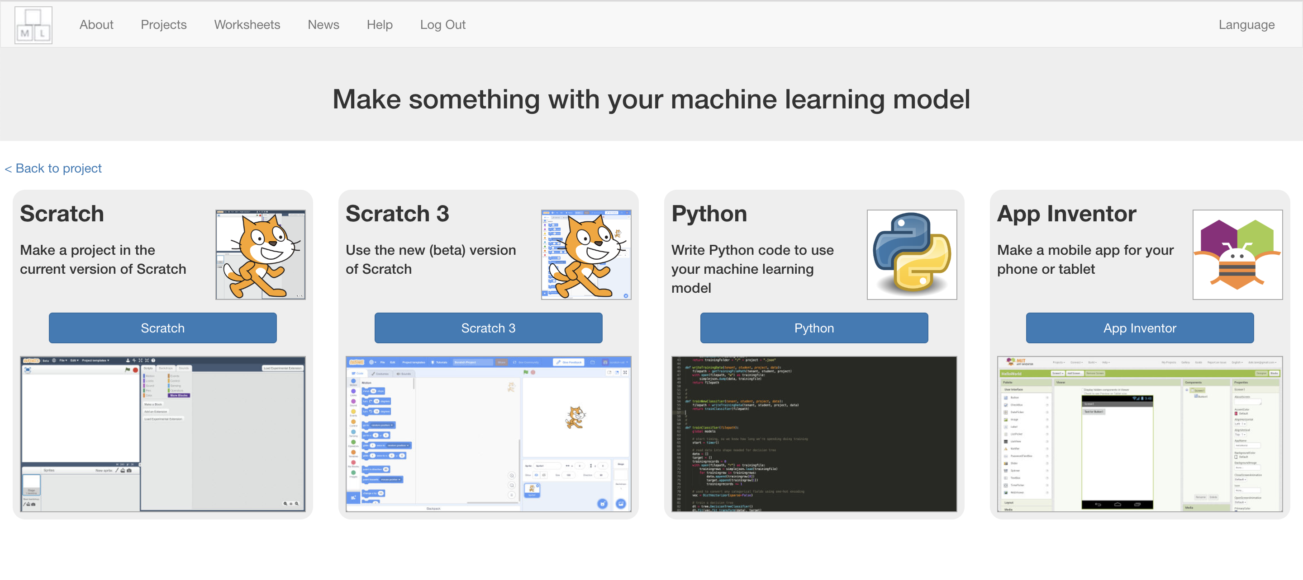

1. 點選“**Open in Scratch 3**”

Click on “**Open in Scratch 3**”  
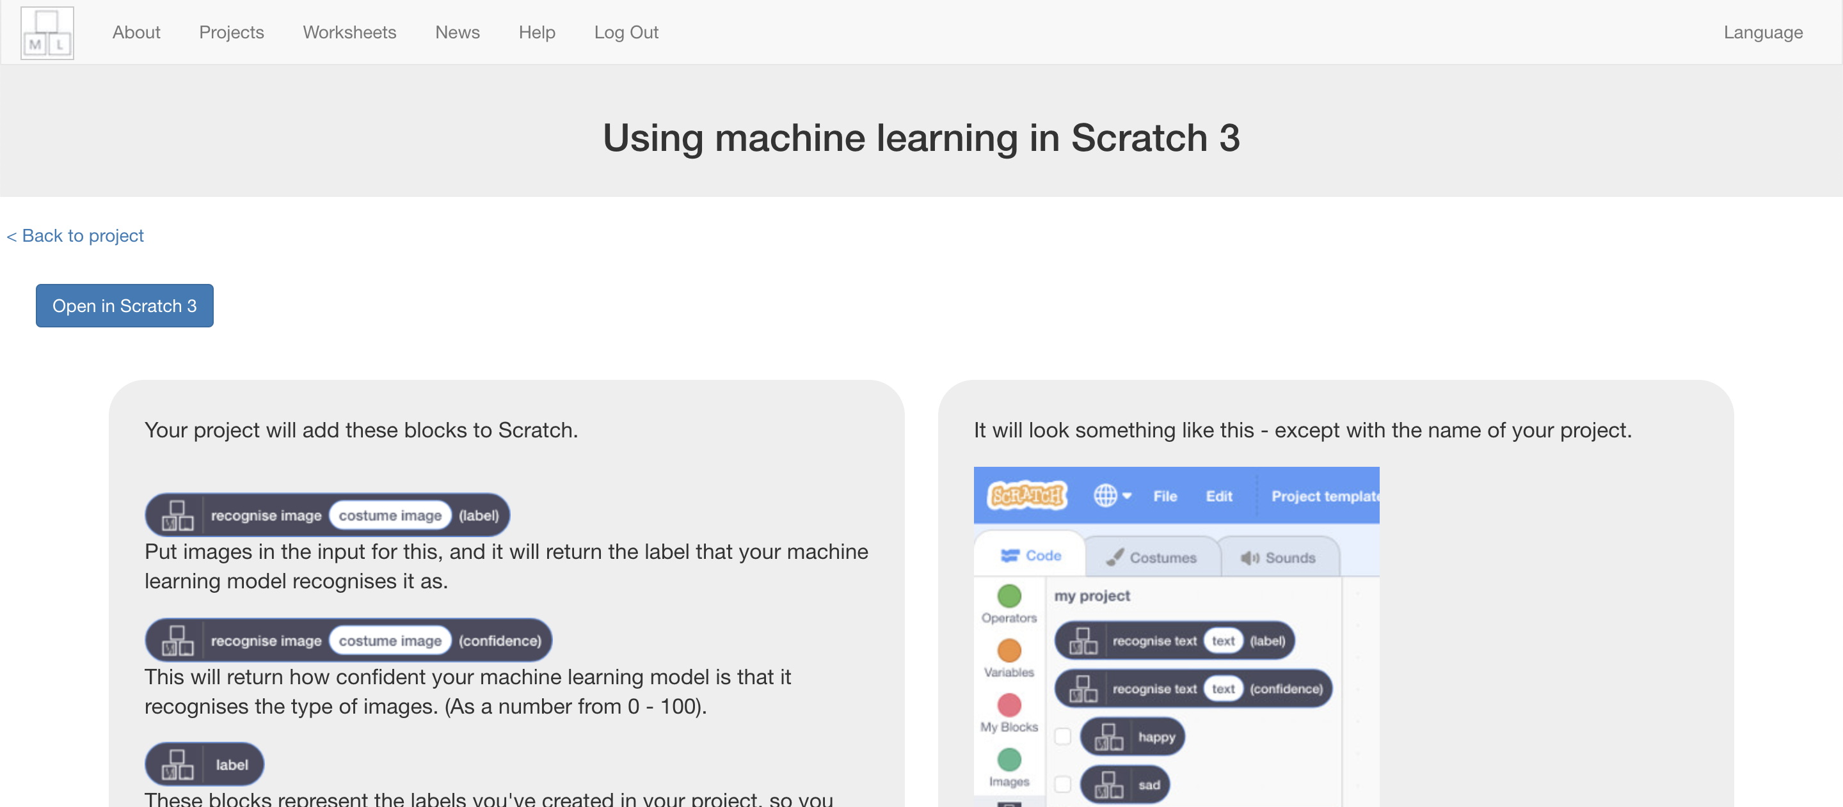

1. 點按“**Try it!**”

Click on “**Try it!**”  
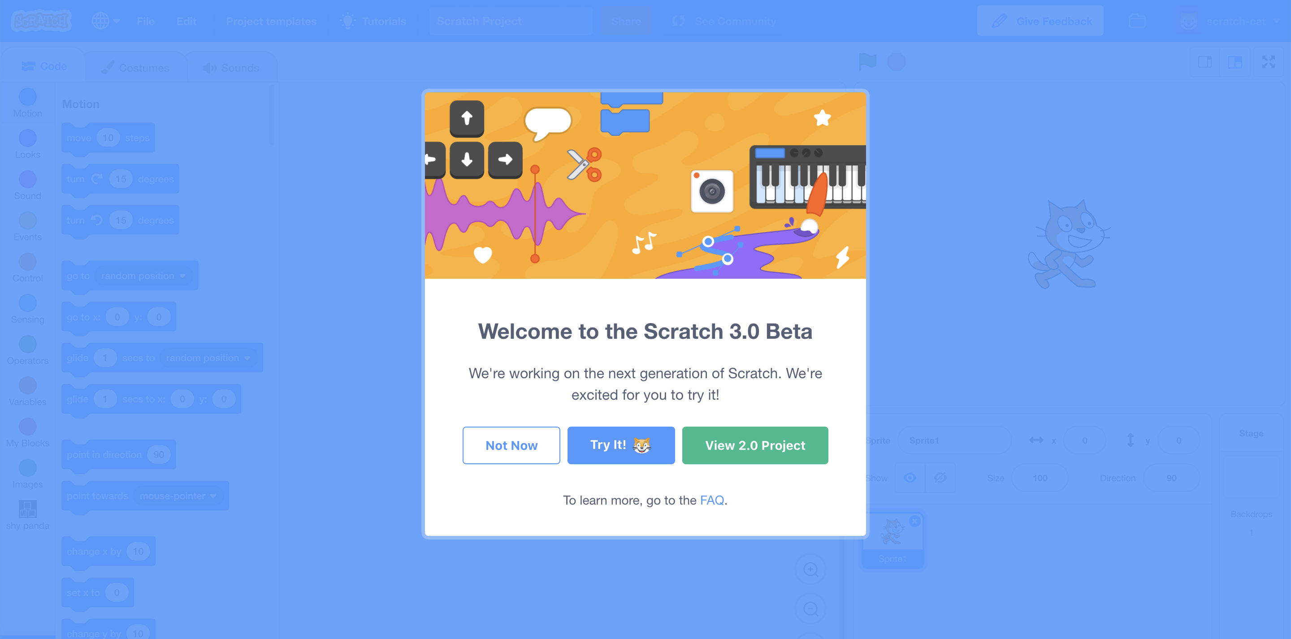

1. 點按“**Project templates**”

Click on “**Project templates**”  
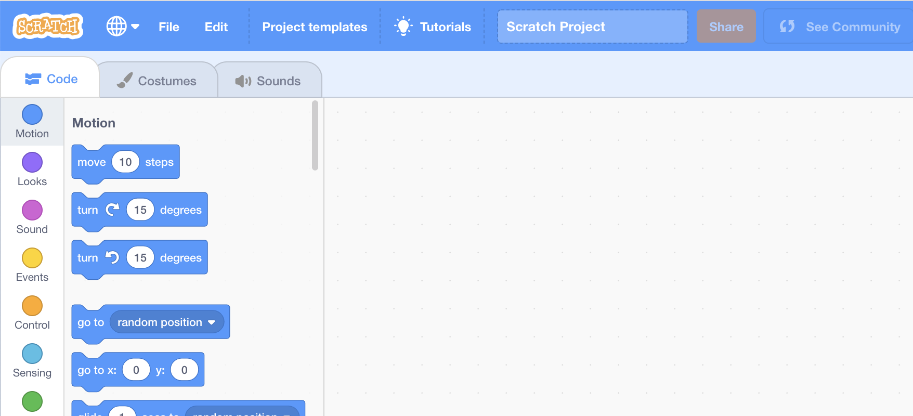

1. 選擇“**Shy Panda**”

*如果你的瀏覽器要求存取權，點選****Allow***

Click on the “**Shy Panda**” template  
*You might need to scroll down to it  
If your browser asks for permission to use the web-cam, click* ***Allow***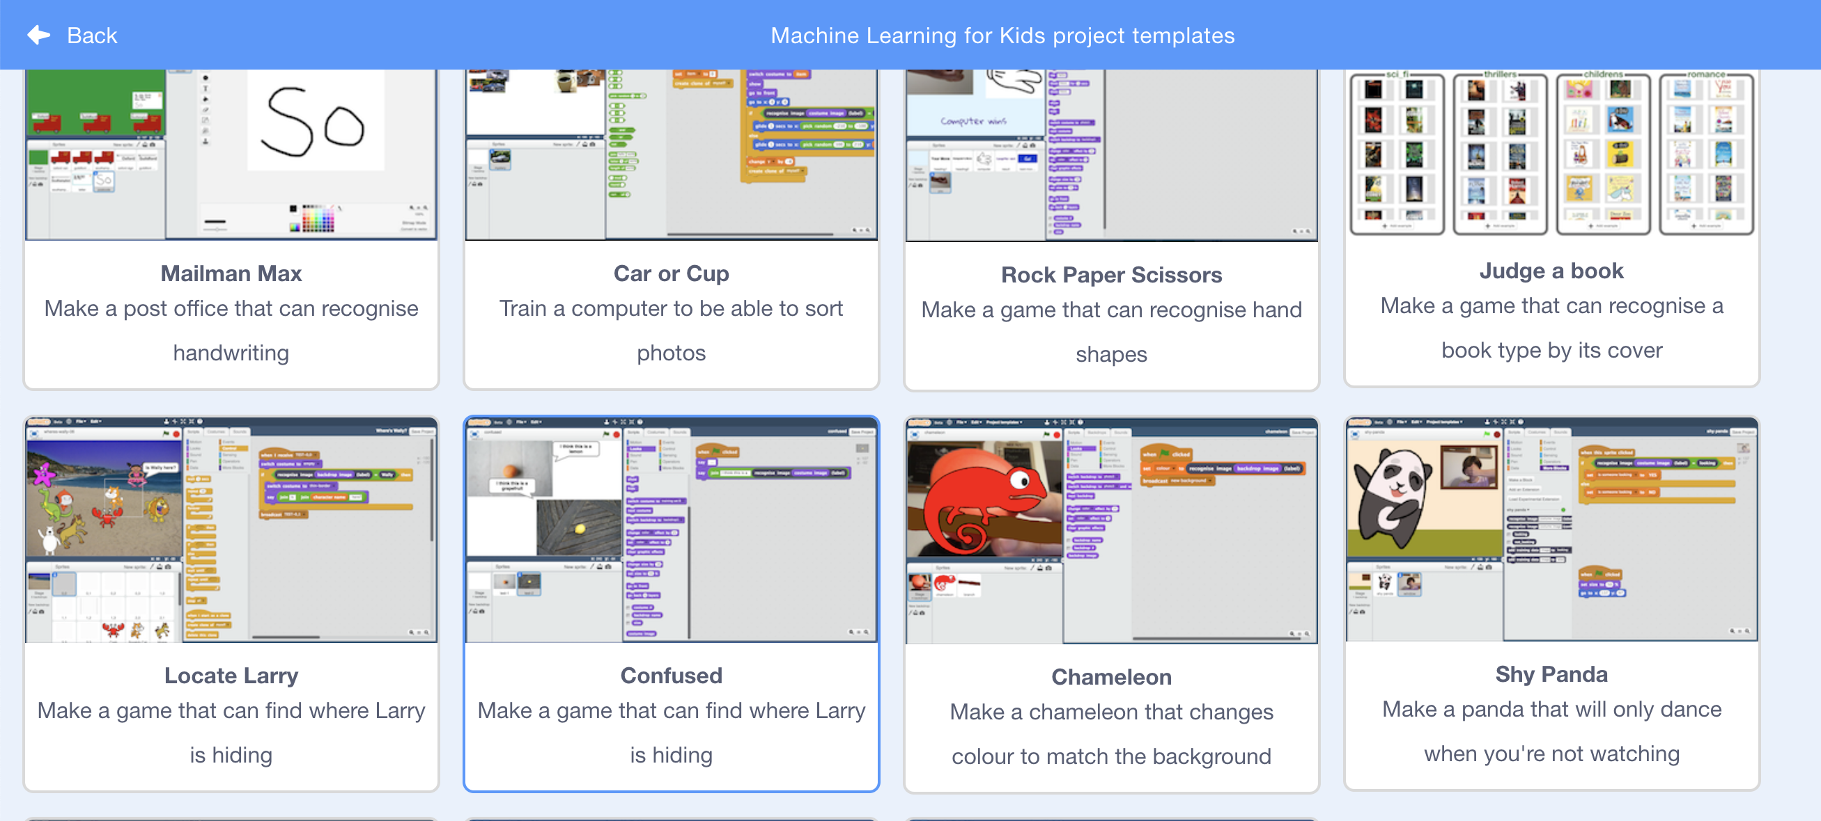

1. 點擊綠旗，熊貓開始跳舞了！

進入下個步驟前，先點選紅色暫停按鈕。

Click on the Green Flag to see the panda dance! *Click the* ***red stop button*** *before moving to the next step.*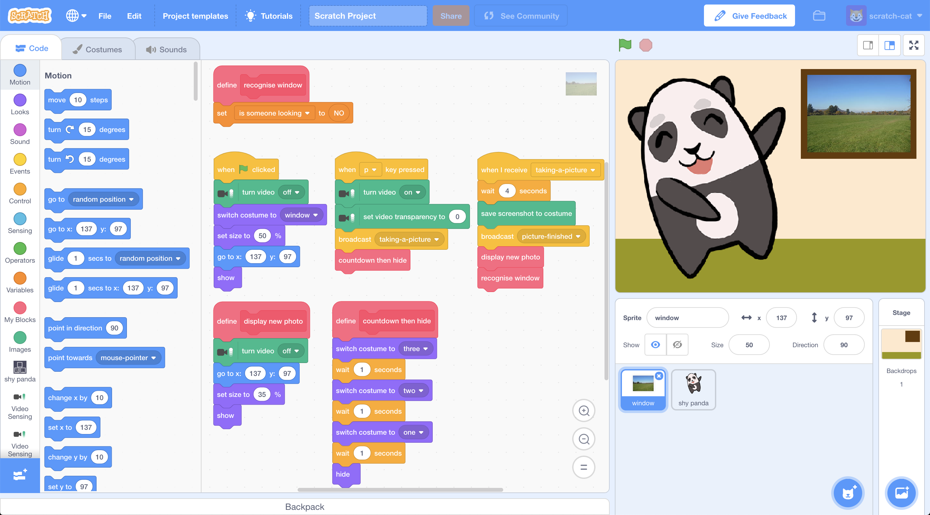

1. 在角色“**window**”的程式區塊中找到“**recognise window**”積木

Find the “**recognise window**” script in the “**window**” sprite  


1. 拖曳程式積木（如下圖）

*如果你是第一次使用Scratch 3，別擔心，這和Scratch2 操作方式非常類似，一樣是在左邊的工具區尋找所需要的積木，拖曳到程式區*

Change the “**recognise window**” script so that it looks like this  
*If you’re new to Scratch 3, don’t worry as it’s very similar to Scratch 2. Scroll through blocks in the toolbox on the left to find the blocks you need.*   
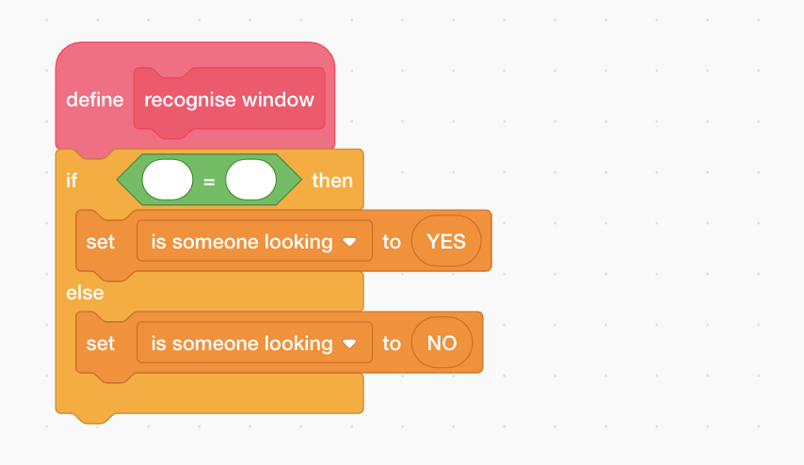

1. 點選工具區的“**shy panda**” ，找到“**recognise image** (costume image) **(label)**”積木

Click on “**shy panda**” in the toolbox and then find the   
“**recognise image** (costume image) **(label)**” block  
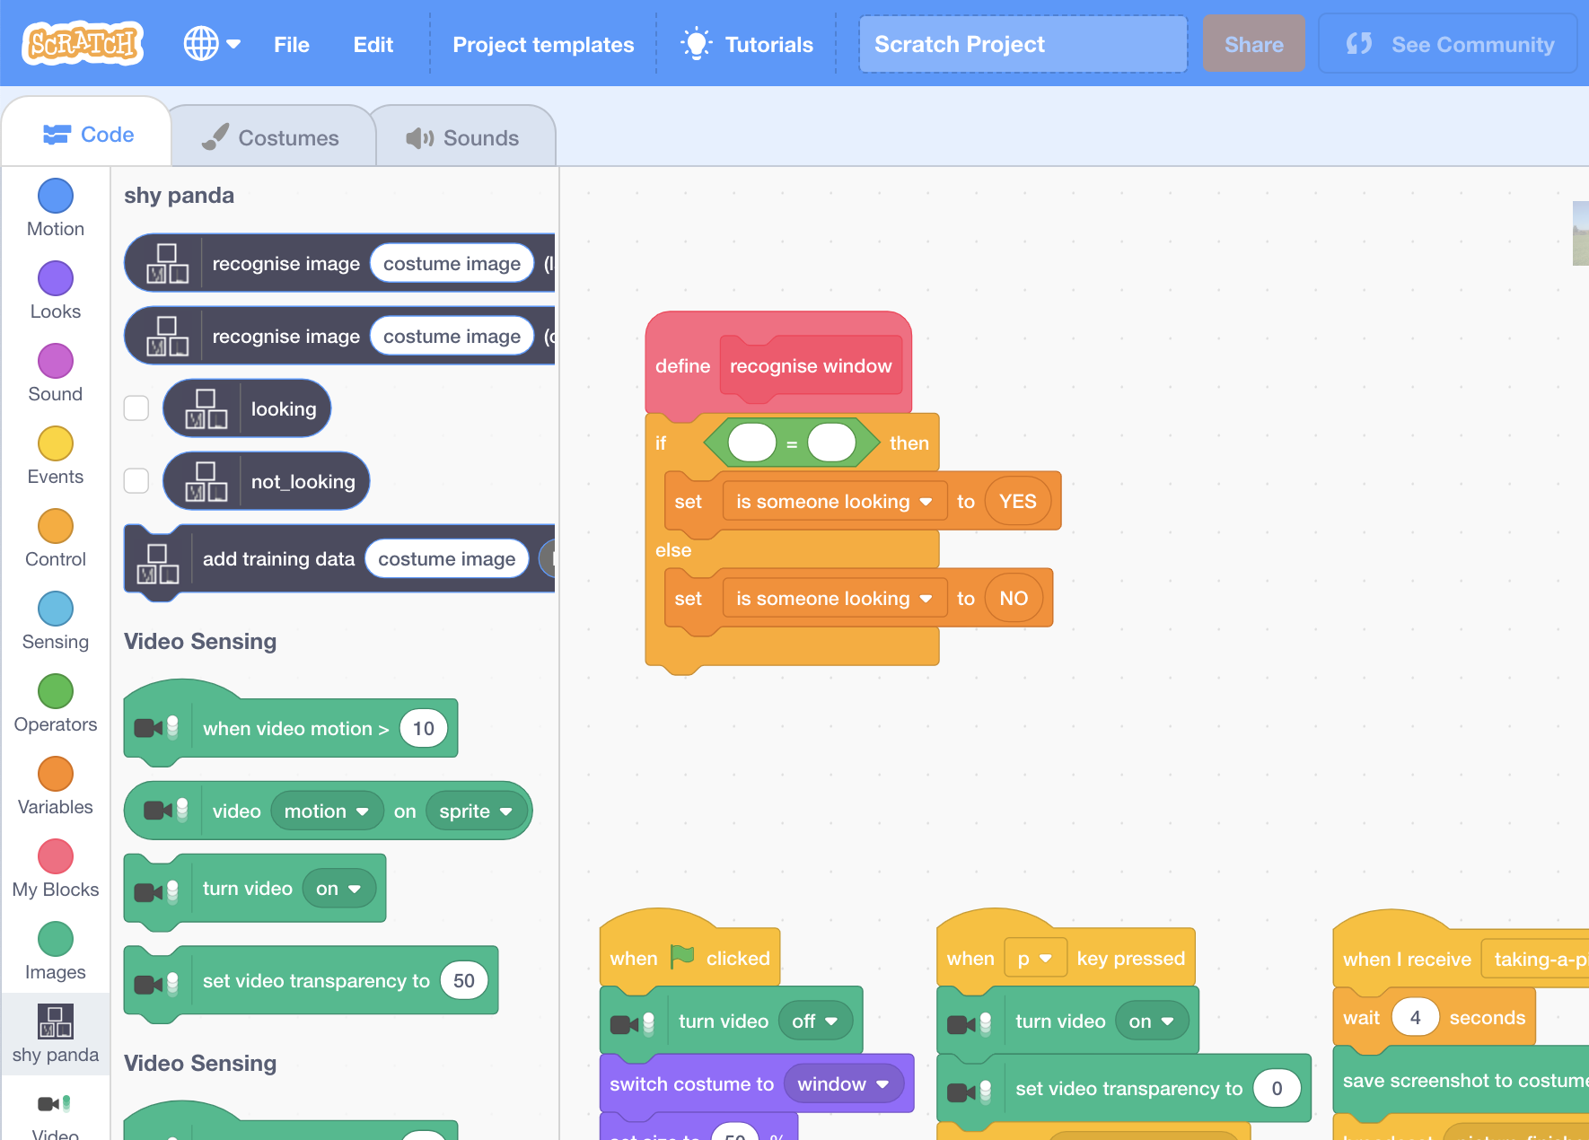

1. 拖曳“**shy panda**”積木更新“**recognise window**”區域的程式

Change the “**recognise window**” script using “**shy panda**” blocks  
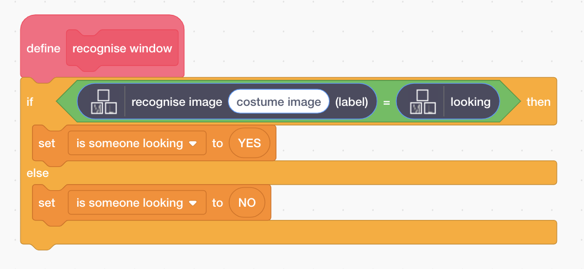

1. 點選工具區的“**images**” ，找到“**costume image**”積木

Click “**images**” in the toolbox and find the “**costume image**” block  
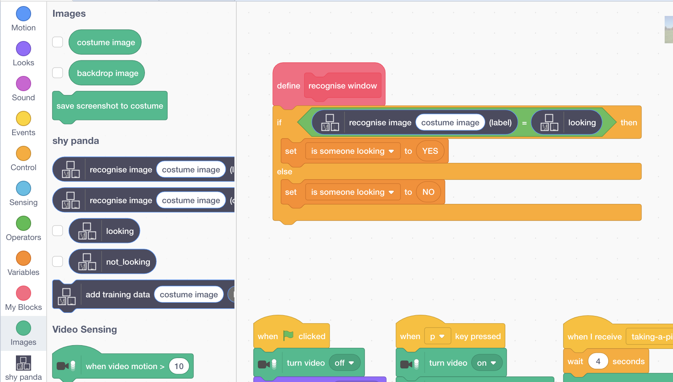

1. 使用“**costume image**”積木完成“**recognise window**”區的程式

Finish the “**recognise window**” script with the costume image block  
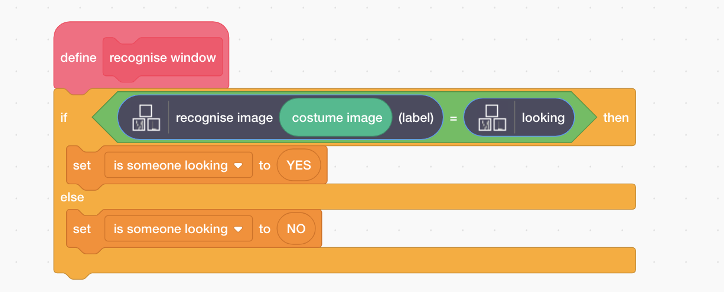

1. 點擊全螢幕

Click the **full-screen** button  
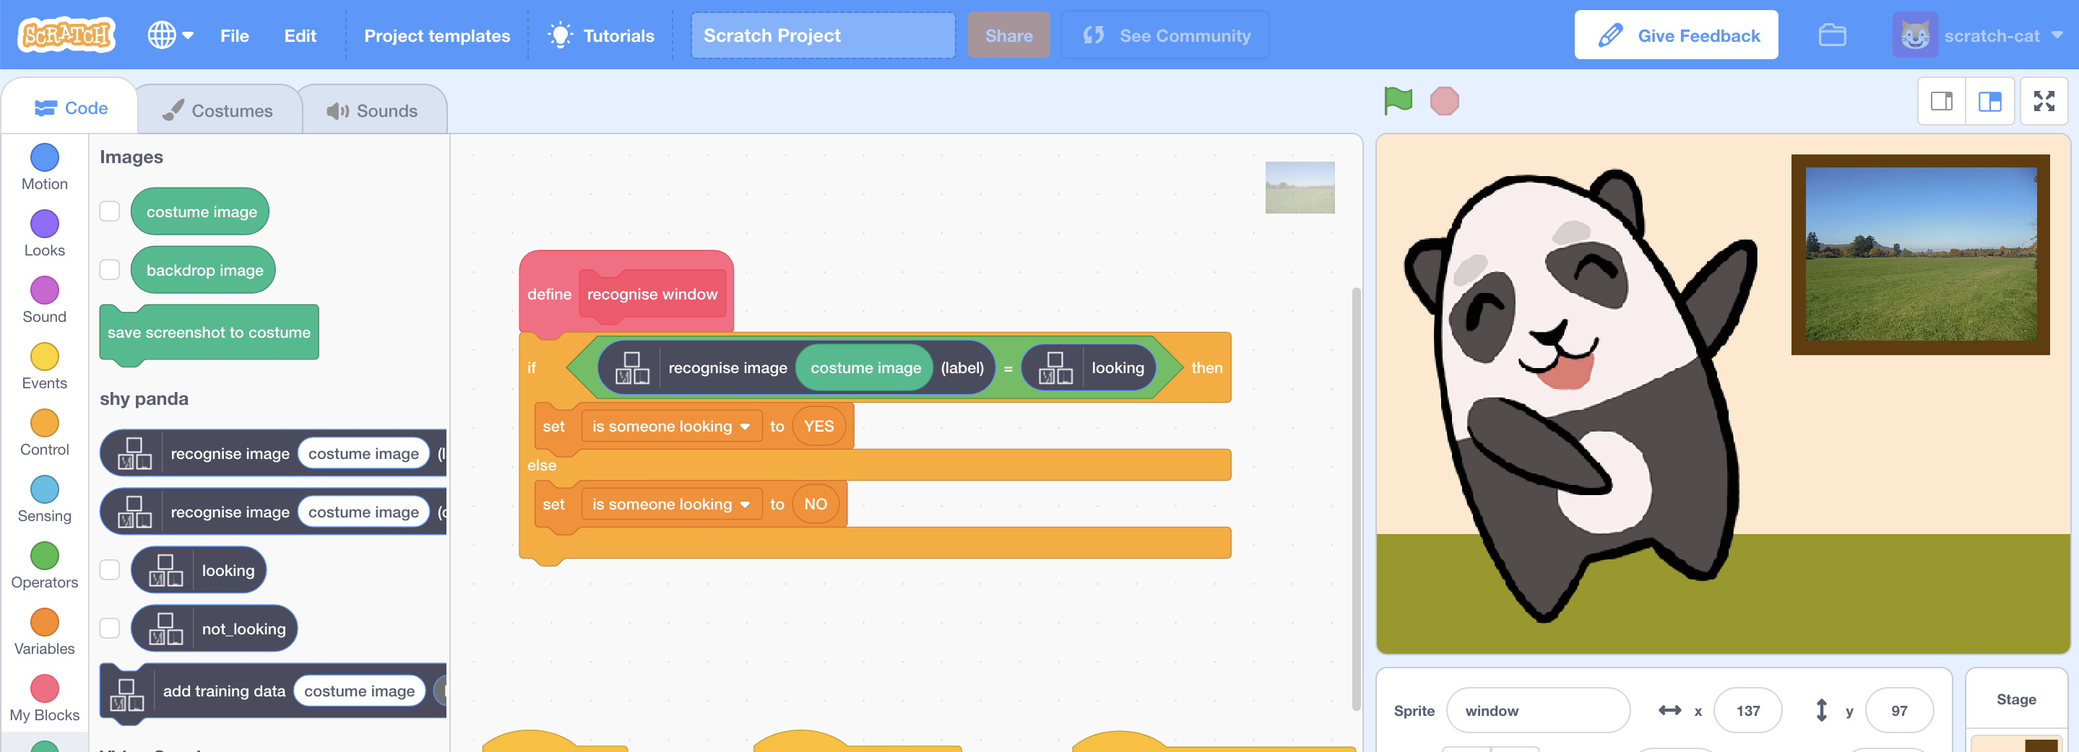

1. 點擊綠旗

Click the **Green Flag** to start the panda dancing again

1. 按下“**P**”鍵，拍張你看著鏡頭的照片

*拍照前有三秒鐘的預備時間。*

*如果模型判別你正對著鏡頭看(“looking”)，那麼熊貓就會停止跳舞，而且會擺出害羞的表情！*

Press “**P**” on your keyboard to take a picture of yourself looking in   
*You’ll get a 3-second countdown before the photo is taken  
If your machine learning model recognises the photo as “looking”, the panda should stop dancing and look embarrassed!*

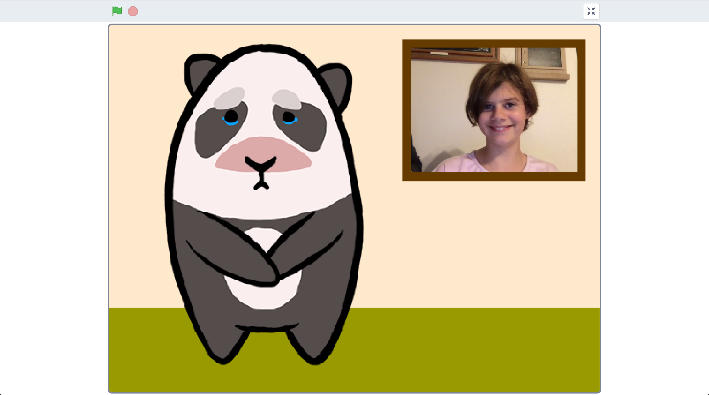

1. 按下“**P**”鍵拍第二張照片，這次遮住你的臉。

*拍照前有三秒鐘的預備時間。*

Press “**P**” again to take a second photo. This time cover your face.   
*You’ll get a 3-second countdown before the photo again.*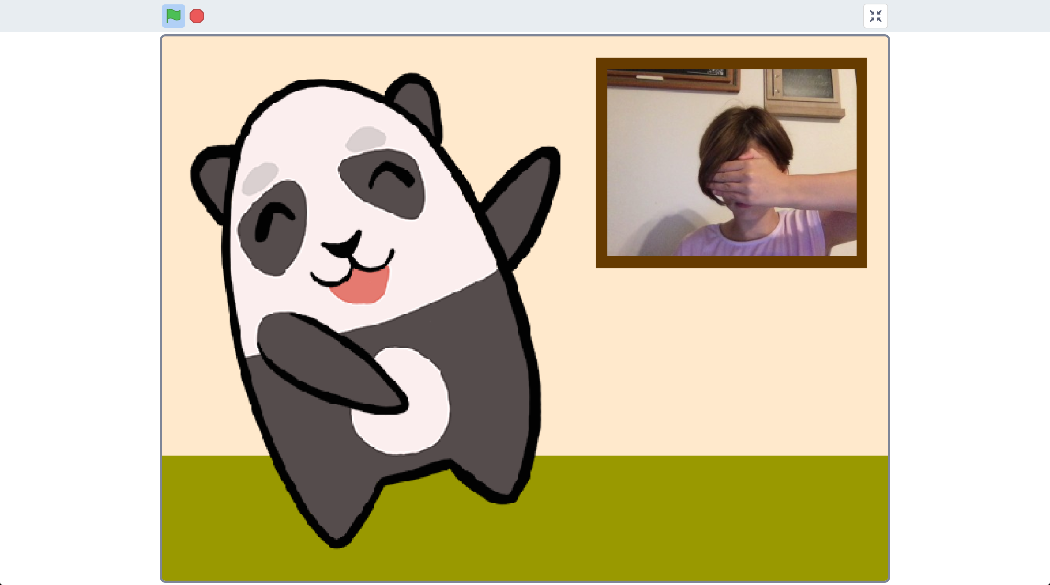

1. 模型會判別你沒有盯著鏡頭看(“not looking”)，所以熊貓會繼續跳舞

The panda should start dancing again, as your machine learning model will recognise that you’re not looking.

1. 存檔

*取消全螢幕，點選檔案，再點選儲存專案*

Save your project  
*Click the* ***full-screen*** *button again   
Click “****File****” -> “****Download to your computer****”*

**你完成了什麼？**

**What have you done?**

你在Scratch裡使用機器學習創造了一隻害羞的熊貓，他會判別照片中的你是否正盯著他看。

You’ve created a shy panda in Scratch that uses machine learning to recognise whether the view at the window is a picture of you looking in.

你所訓練的機器學習模型是個照片分類器(image classifier)，能將照片分成兩類：looking和 not looking。

The machine learning model that you’ve trained is an image classifier, that is able to classify photos as one of two classes – either looking or not looking.

如果給越多範例照片，模型應該就能更準確的判別出照片中的人是否正盯著鏡頭看。

The more examples you give it, the better it should get at recognising whether or not you’re looking at it.

**延伸活動**

**Ideas and Extensions**

現在你已經完成了這個專案，要不要試試下面的點子？或者，自己想一個？

Now that you’ve finished, why not give one of these ideas a try?

Or come up with one of your own?

**畫出屬於你自己的角色**

**Draw your own character**

你不一定只能使用熊貓，要不要試試看畫屬於你自己的角色？

一共需要三個造型：兩個用來呈現跳舞的樣子，第三個則是害羞的樣子。

You don’t have to use the panda in the project template. Why not draw your own character? You’ll need two sprites to be able to animate it dancing, and a third sprite of it looking shy.

**改善訓練**

**Improving your training**

試試看讓同學來測試，熊貓一樣能正確判別嗎？

Try testing it with your classmates. Does the panda still behave correctly?

如果照片中根本沒有人呢？

What about if there’s no one there at all?

你可以怎麼改善訓練，讓熊貓遇到不同狀況時都能做出正確的反應呢？

How can you improve the training so that the panda does the right thing for these sorts of cases?